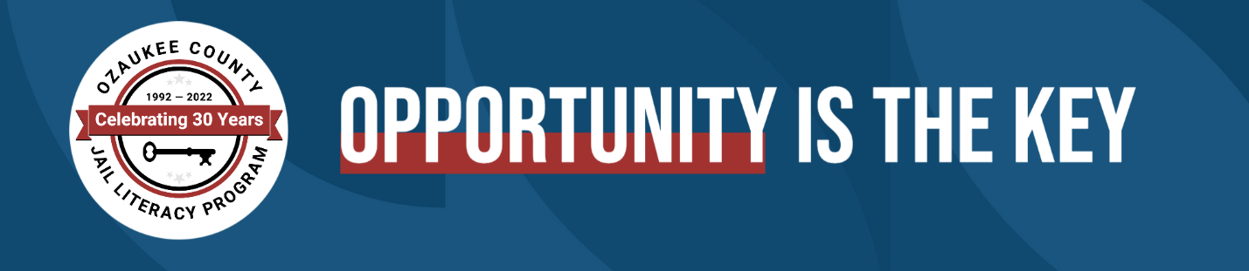

Ozaukee County Jail Literacy Program

is seeking a part-time Math/Science teacher

May 10, 2022
The OCJLP is seeking a part-time math and science teacher for a multilevel class of up to 10 adult incarcerated learners in the Ozaukee County Jail facility to help students improve their literacy skills and to prepare students to earn their GED/HSED credentials.
Hours are T/W/Th 9:15–11:15 a.m. and 12:45–2:45 p.m.
Candidates will have a Bachelor’s or Master’s degree in education or in the math and science fields of study, demonstrate a commitment and ability to serve a diverse community, and be willing to undergo a background check and PREA training. Student teachers, or pre-certified teachers with relevant experience will be considered.
Interested candidates should send a cover letter, resume, and a copy of a teaching certification or transcripts to info@ozaukeejailliteracy.org.

