Ozaukee County Jail Literacy Program

Adult Computer/Digital Literacy Instructor Wanted
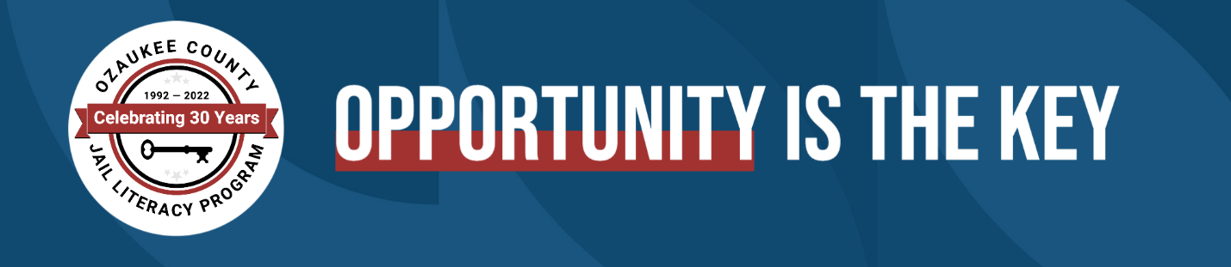

June 30, 2022
If you’re comfortable with technology and would like to share your knowledge with others, the Ozaukee County Jail Literacy Program needs you.
We are seeking a computer/digital literacy instructor for in-person instruction at the Ozaukee County Jail facility to teach basic-to-advanced computer skills to adult students. This includes computer basics, navigating the internet, sending and receiving emails, and creating documents, spreadsheets and slideshows with Microsoft Office or Google products.
Candidates must have strong computer and technology skills, demonstrate a commitment and ability to serve a diverse community, and be willing to undergo a background check.
Commitment is 2 hours per week (day or evening hours based on your availability). Pay is $25/hour.
Interested candidates should email cover letter, and resume to info@ozaukeejailliteracy.org

