Ozaukee County Jail Literacy Program

Art Instructor Wanted
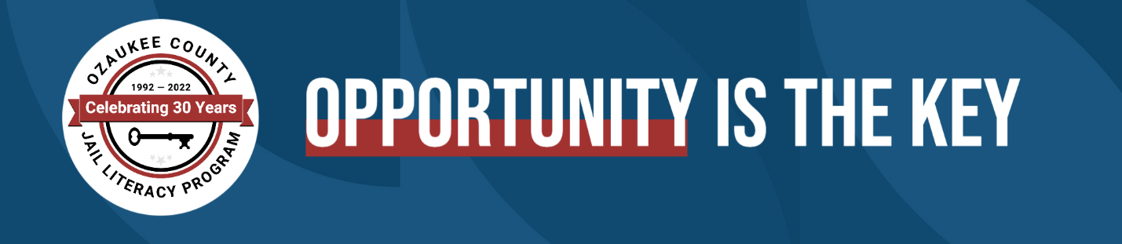

June 30, 2022
If you’re comfortable with making art and promoting imagination, and would like to share your knowledge with others, the Ozaukee County Jail Literacy Program needs you!
We are seeking an art teacher for in-person instruction at the Ozaukee County Jail facility to teach basic art techniques and various forms of creative expression to incarcerated adults in a small classroom setting (5 students).
Candidates must have an art, or art therapy background, have both produced and taught art, demonstrate a commitment and ability to serve a diverse community, and be willing to undergo a background check.
Commitment is 2 hours per week (day or evening hours based on your availability). Pay is $25/hour.
Interested candidates should email cover letter, and resume to info@ozaukeejailliteracy.org

